Latest ISO downloaded from:

https://www.microsoft.com/en-gb/software-download/windows10

Download Tool Now > Media Creation Tool. > Create Installation Media for another PC.

Results from tests:

***1.a) original (untouched) Win10 v1607 image***

***\*Boots to Install menu but only discovers and shows SATA / SSD (NON RAID) devices only. Does not see the RAID Array.***

***2.b) modded Win10 v1607 image, where the "bad MS driver" named scsidev.inf had been removed (BOOT.WIM+INSTALL.WIM)***

*Loaded INSTALL.WIM. Unable to delete from “Components” - Microsoft : scsidev.inf. Its greyed out.

Had to go back to source and Explore Mount Point.

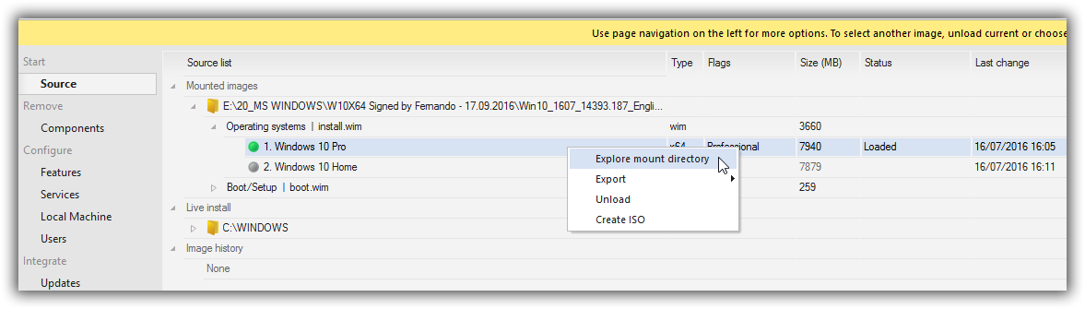

*Searched for all instances of scsidev.inf files. Unable to delete or rename unless permission are changed? Used the TAKE OWNERSHIP reg file to delete them.

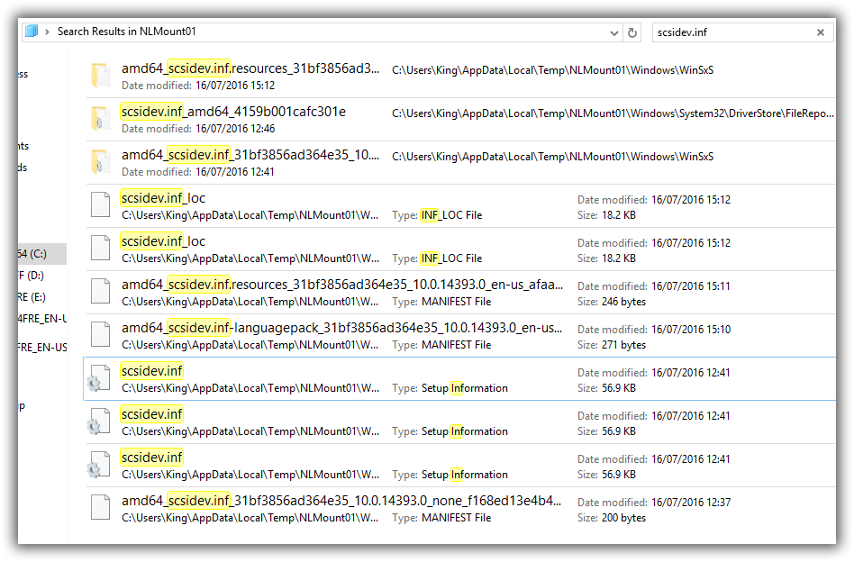

*Below is the only data left that has reference to scsidev.inf

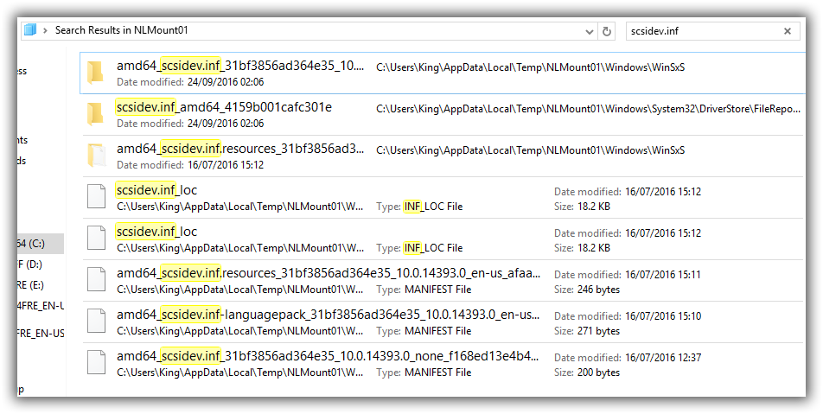

*Unloaded image ticking box to save changes.

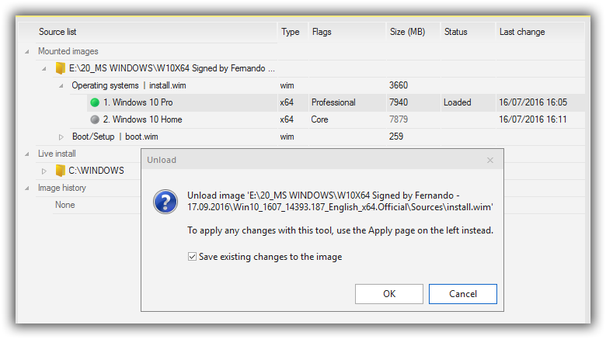

*Repeated above process with the BOOT.WIM (Microsoft Windows Setup (X64))

*All references to scsidev.inf deleted.

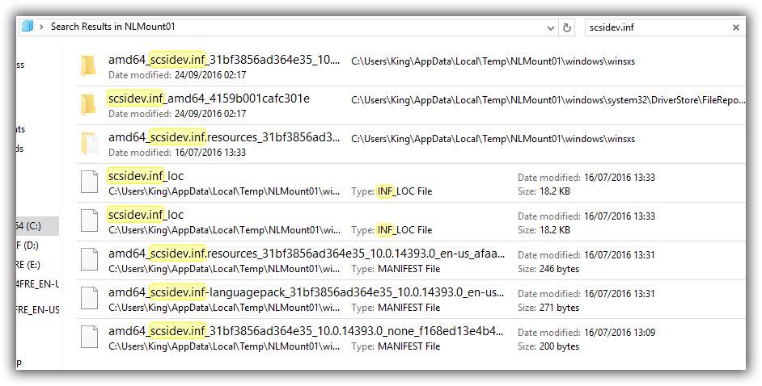

*Unloaded Image saves changes. Applied and Process options taken. Created TEST ISO image.

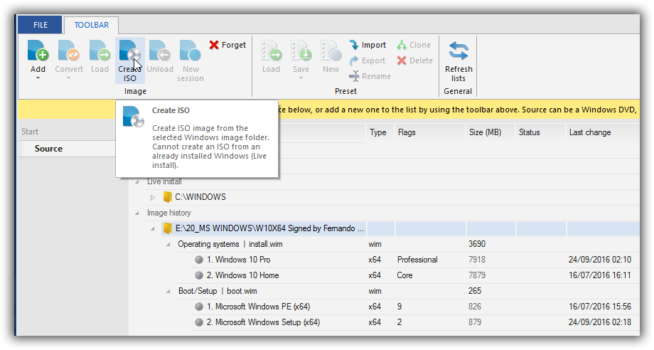

***\*Result:***

***\*Boots to Install menu but only discovers and shows SATA / SSD (NON RAID) devices only. Cannot see the Raid Array.***

***3.c) modded Win10 v1607 image, where the in-box NVIDIA nForce SATARAID drivers had been replaced by the "test3" or "new" variant of my mod+signed 32/64bit nForce SATARAID drivers v11.1.0.43 or v9.99.09 (BOOT.WIM+INSTALL.WIM). Using default built in scsidef.ini.***

***Using a NEWLY extracted Window image….!!!***

***Scsidev.inf is present. Removing MS Built in nVidia drivers and adding Fernando’s drivers v9.99.09 for both INSTALL and BOOT.WIM***

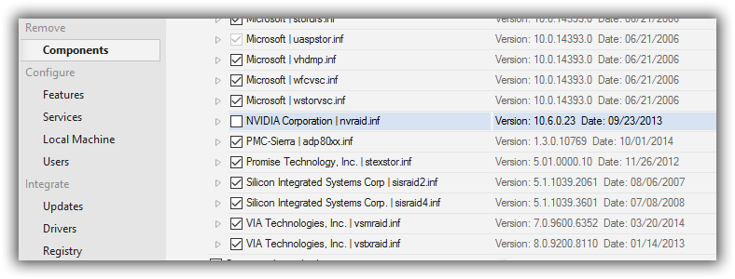

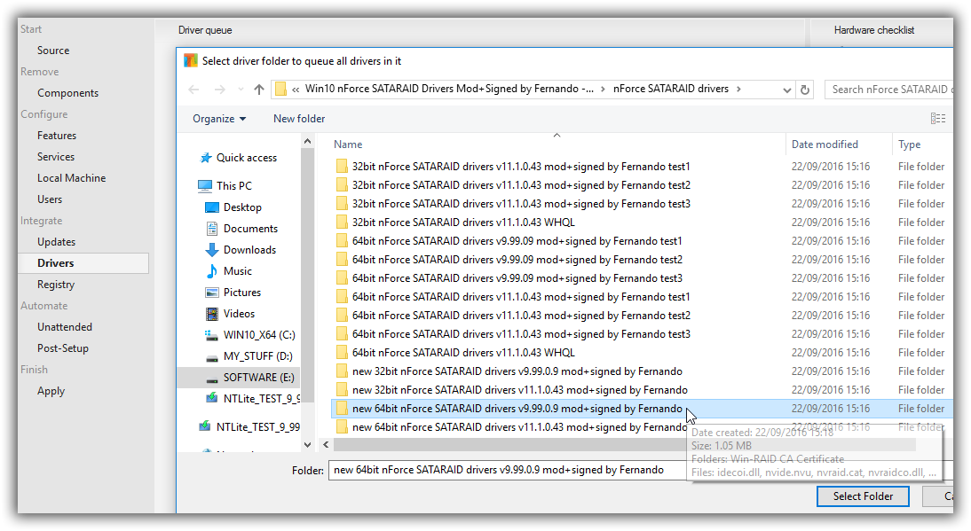

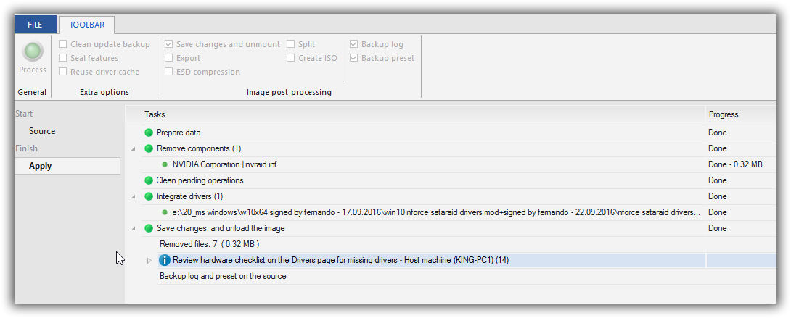

***\*Testing with the v 9.99.09 / v11.1.0.43 set of drivers. Removed Built in drivers from INSTALL and BOOT WIMS and replaced with Fernando’s. Applied and Process options taken. ISO created.***

***\*SAME AS ABOVE ERROR for X64 v11.1.0.43. See’s the RAID array only. Doesn’t pick up the non-Raid SSD. Unable to proceed past NEXT due to the error mentioned above.***

***\*ERROR – We couldn’t create a new partition or locate an existing one. See the set up log files.***

Unable to proceed any further.

***4.d) modded Win10 v1607 image, where the "bad MS driver" named scsidev.inf had been removed and the in-box NVIDIA nForce SATARAID had been replaced according point c) (BOOT.WIM+INSTALL.WIM)?***

*Testing with the x64 v9.99.09 set of drivers first. Removed Built in drivers from INSTALL and BOOT WIMS and replaced with Fernando’s. Applied and Process options taken. ISO created.

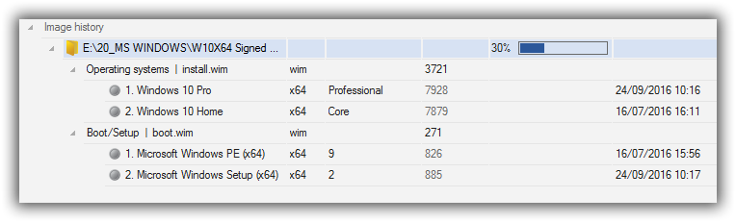

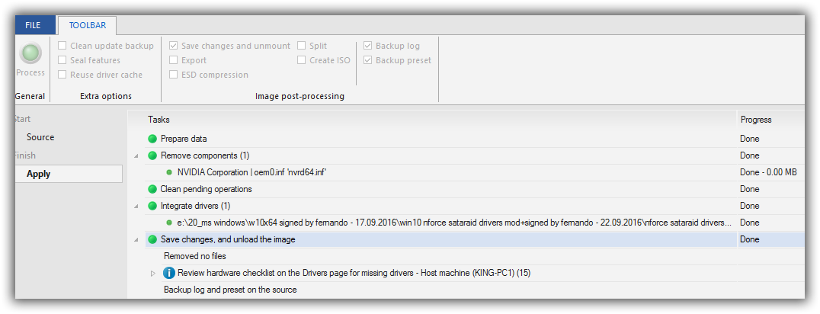

***\*Results for x64 v9.99.09***

***\*Its finds the nVidia RAID array ONLY. (2 x WD 150GB drives RAID0) 279GB as an DRIVE 0 unallocated space.***

***It DOEST NOT find any non-raid SSD.***

I can select NEW and create a partition.

I can select FORMAT and DELETE.

It DOES NOT create the bootable system recovery area during the format. It normally creates a default 500MB partition and leaves the rest of the disk as free space?

***\*ERROR – We couldn’t create a new partition or locate an existing one. See the set up log files.***

I tried using SHIFT F10 for a command prompt and diskpart command:

Start DISKPART

Type LIST DISK and identify your HDD disk number (from 0 to n disks).

Type SELECT DISK <n> where <n> is your HDD disk number.

Type LIST PARTITION

Type SELECT PARTITION <n> where <n> is your partition number of the last drive

Type CREATE PARTITION PRIMARY

Type ACTIVE

Type FORMAT FS=NTFS QUICK

Type ASSIGN

Type EXIT twice (one to get out of DiskPart, the other to exit the command line tool)

So even if you do the above and hit refresh on the original window - Where do you want to installation Windows?

***It now lists the disk as DISK 0 PARTITION 1 - but you still get the Error msg when clicking NEXT.***

Unable to proceed any further.

***\*Testing with the v11.1.0.43 set of drivers first. Removed Built in drivers from INSTALL and BOOT WIMS and replaced with Fernando’s. Applied and Process options taken. ISO created.***

***\*SAME AS ABOVE ERROR for X64 v11.1.0.43. See’s the RAID array only. Doesn’t pick up the non-Raid SSD. Unable to proceed past NEXT due to the error mentioned above.***

One Final test I did was to take a clean 1607 iso. Replace the scsidev.ini with an older one from a 1511 iso.

Leaving the built-in nVidia drivers for both INSTALL and BOOT WIMS.

windows/inf/scsidev.inf.1607.ORIG

windows/inf/scsidev.inf (from 1151)

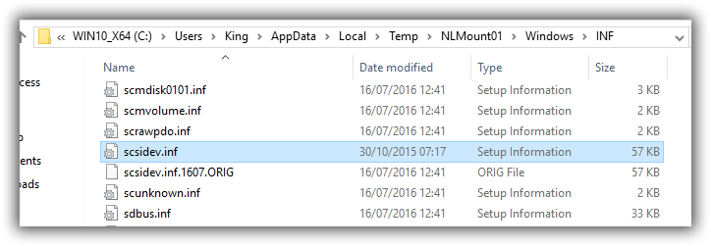

\scsidev.inf_amd64_4159b001cafc301e (had to take Ownership of Folder as well…)

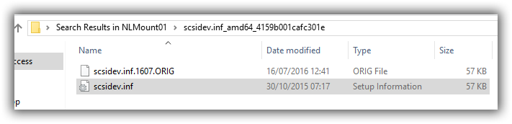

\amd64_scsidev.inf_31bf3856ad364e35_10.0.14393.0_none_f168ed13e4b4fd31

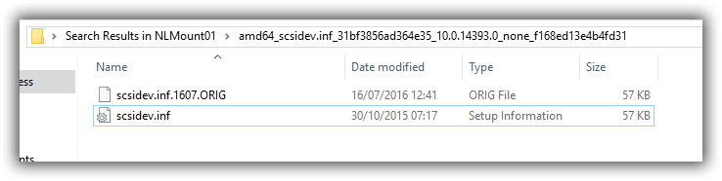

***\*Results:***

***\*Only sees the non-raid SSD. Does not pick up the RAID array.***

Second Final test I did was to take a clean 1607 iso. Replace the scsidev.ini with an older one from a 1511 iso.

Removing the built-in nVidia drives and replace them with Fernando’s.

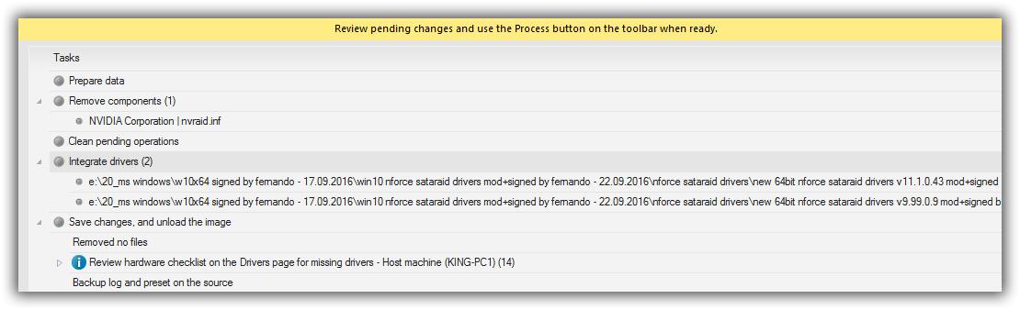

***\*Results:***

***\*See’s the RAID array only. Doesn’t pick up the non Raid SSD. Unable to proceed past NEXT due to the error,***

***\*ERROR – We couldn’t create a new partition or locate an existing one. See the set up log files.***